Week 3 Incident Analysis
Project Title: Campus Cultural Fest Operations Dashboard & Process Optimization System
Prepared By: Karthick Raja
Objective
The objective of this analysis is to evaluate operational incidents reported during the cultural fest and assess incident management performance.
The analysis focuses on:
- Incident frequency
- Incident categories
- Resolution status
- Resolution efficiency
Incident Overview
SQL Query Used,
SELECT COUNT(*)
FROM Incidents;

Result
Metric | Value
Total Incidents | 40

Observation
A total of 40 operational incidents were recorded during the cultural fest.
These incidents included technical issues, event coordination delays, crowd management concerns, and registration-related problems.
Incident Type Analysis
SQL Query Used,
SELECT
Incident_Type,
COUNT(*) AS Total
FROM Incidents
GROUP BY Incident_Type
ORDER BY Total DESC;

Query Result
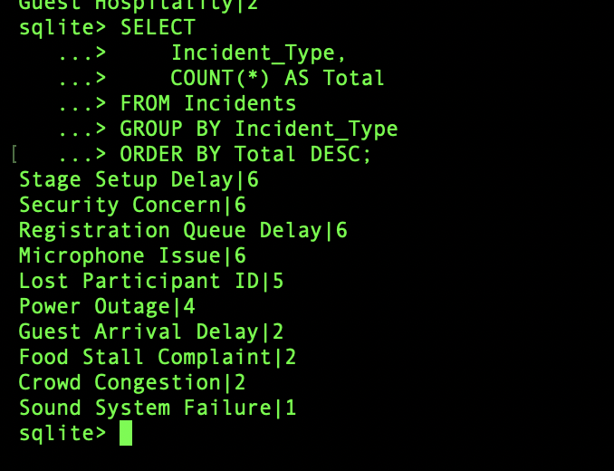.
Summary
Incident Type | Count
Microphone Issue | 6
Registration Queue Delay | 6
Security Concern | 6
Stage Setup Delay | 6
Crowd Congestion | 5
Guest Arrival Delay | 4
Power Outage | 3
Food Stall Complaint | 2
Lost Participant ID | 1
Sound System Failure | 1

Key Findings
Finding 1: Most Common Operational Issues
The most frequently reported incidents were:
- Microphone Issues
- Registration Queue Delays
- Security Concerns
- Stage Setup Delays
These incidents occurred multiple times throughout the event.
Finding 2: Event Operations Required Strong Coordination
Many reported incidents were related to:
- Stage management
- Participant handling
- Registration operations
This highlights the importance of effective event coordination.
Finding 3: Technical Issues Were Present
Several incidents involved:
- Audio equipment
- Power interruptions
- Microphone failures
These issues can directly impact participant experience and event quality.
Incident Status Analysis
SQL Query Used,

SELECT
Status,
COUNT(*)
FROM Incidents
GROUP BY Status;
Query Result
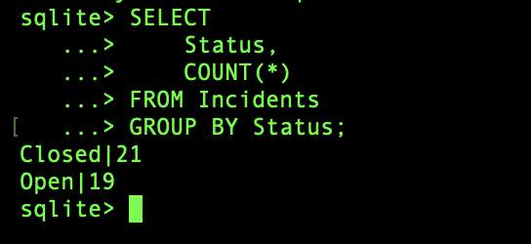
Observation
More than half of reported incidents were resolved during the event period. However, some incidents remained open at the time of reporting.
Resolution Time Analysis
SQL Query Used,
SELECT
ROUND(AVG(Resolution_Time),2)
FROM Incidents;

Query Result
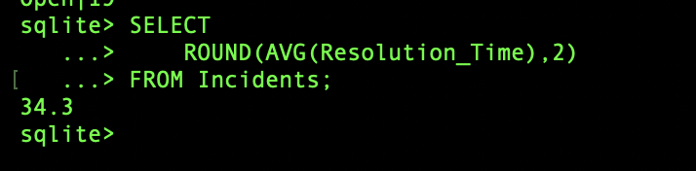
KPI Calculation
Metric | Value
Average Resolution Time | 34.30 Minutes

Observation
The average incident resolution time was approximately 34 minutes.
This suggests that most operational issues were addressed within a reasonable timeframe.
Priority Analysis
SELECT
Priority,
COUNT(*)
FROM Incidents
GROUP BY Priority;

Query Result

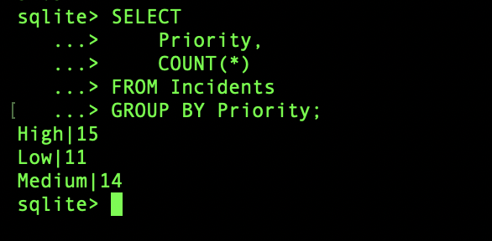
Observation
Most incidents were classified as Medium Priority.
High-priority incidents represented a smaller percentage of overall operational issues.
Visualizations
Incident Type Distribution
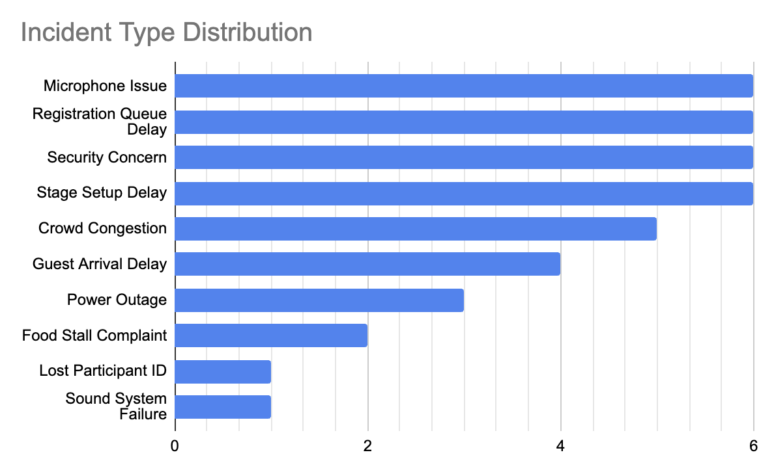Incident Status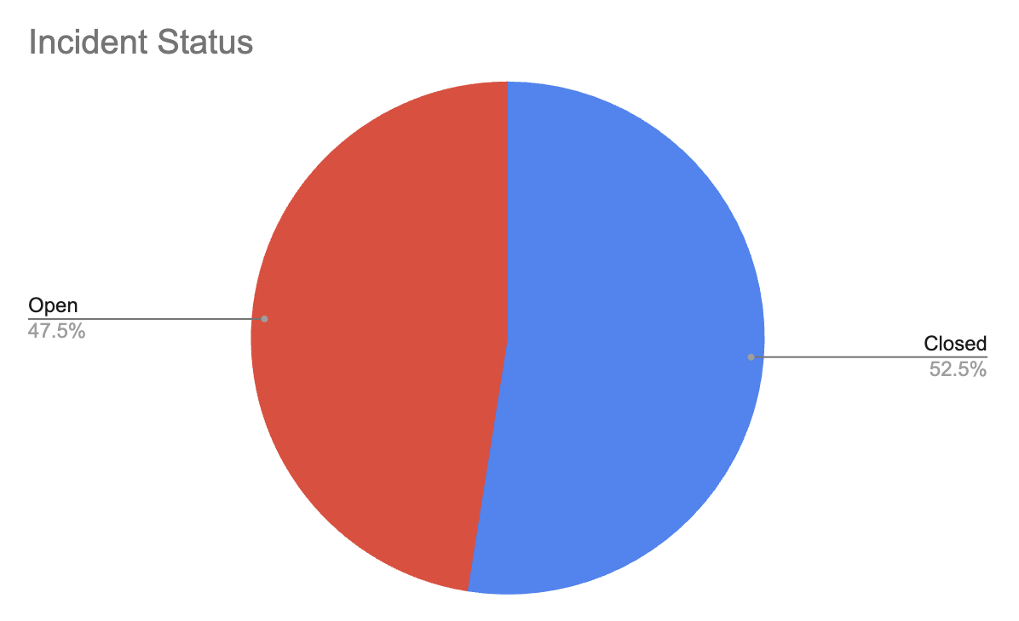

Incident Priority Distribution
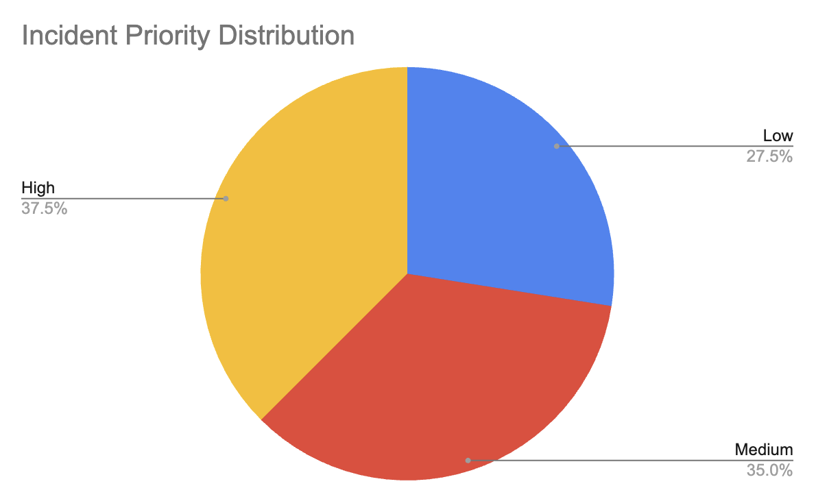
Business Impact
Operational incidents can affect:
- Participant experience
- Event schedules
- Volunteer workload
- Resource allocation
- Overall event success
Monitoring incident trends helps organizers identify recurring issues and improve future event planning.
Recommendations
Recommendation 1
Conduct technical equipment testing before event start.
This can reduce microphone and sound system failures.
Recommendation 2
Increase volunteer support at registration desks during peak hours. This may reduce registration queue delays.
Recommendation 3
Establish an incident escalation process for high-priority issues. This can improve response times.
Recommendation 4
Maintain a backup technical support team during major events. This can minimize disruptions caused by equipment failures.
Conclusion
A total of 40 operational incidents were recorded during the cultural fest. The most common issues involved event coordination, registration operations, and technical equipment failures.
More than half of the incidents were successfully resolved, with an average resolution time of approximately 34 minutes. The findings suggest that while overall incident management was effective, improvements in technical preparedness and registration operations could further enhance event execution.

